GIT - PROJECT

# Problem Statement:

Build a branching model as depicted in this figure

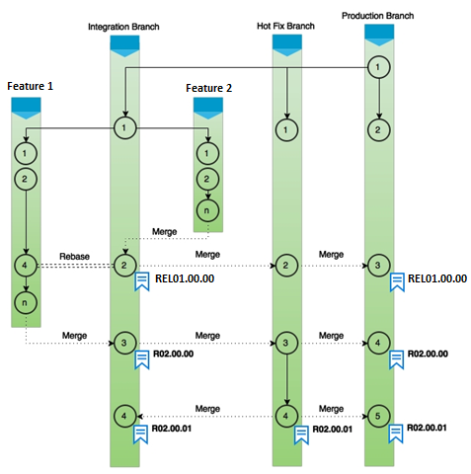

1. Start with the production branch and then create a HotFix branch and Integration branch
2. Subsequently have Feature 1 and 2 branches that integrate as shown in figure
3. Ultimately integrate all features into HotFix branch and then to Production branch